Student’s assessment number………………………….
FORM TWO PRE MOCK
PHYSICS
Time: 2:30 Hours APRIL 2026
Instructions
- This paper consists of sections A, B and C with a total of ten (10) questions.
- Answer all questions.
- All answers must be written in the spaces provided.
- All writing must be in blue or black ink, except drawings which must be in pencil.
- Communication devices and any unauthorized materials are not allowed in assessment room.
- Write your assessment number at the top right corner of every page.
- Where necessary the following constants may be used
- Acceleration due to gravity, g = 10 ms⁻²
- Density of water, ρ = 1000 kgm⁻³
- Pie, π = 3.14
SECTION A (15 Marks)
Answer all questions in this section
- For each of the following items (i) – (x), choose the correct answer from among the given alternatives and write its letter beside the item number in the answer booklet provided.
(10 marks)
- The properties of electromagnetic force are:
- It is attractive or repulsive in nature.
- It is a non-central force
- It is stronger than gravitational force.
- It is a long-range force
- It does not depend on charges of the objects involved.
- 1,2,3,4 and 5 C. 1, 3 and 4
- 1, 2 and 3 D. 1,3,4 and 5

Student’s assessment number………………………
- What is the reading of the micrometer screw gauge in figure 1?
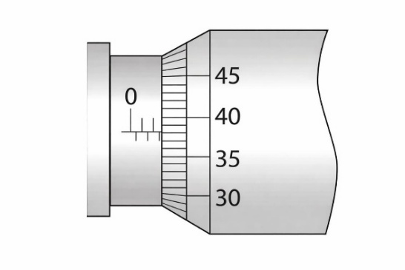
Figure 1
- 2.88 mm B. 38 mm C. 0.288 mm D. 2.88 cm
- What should you do if you find yourself outdoors during a severe thunderstorm?
- take shelter under the nearest tree C. stand under power lines.
- move to higher ground. D. hides in a ditch.
- A student is investigating the energy changes when a ball is dropped from a height. The figure 2 illustrates the energy changes when the ball is released at three different positions.
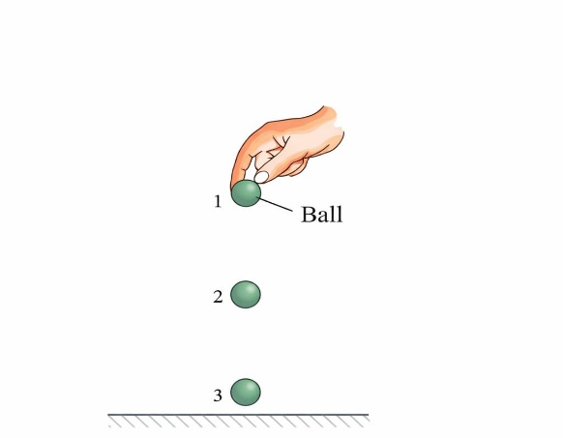
Figure 2
Ignoring the effect of air resistance, which statement about the total energy of the ball is correct?
- It is the same at all points C. It is greatest at point 1
- It is greatest at point 2 D. It is greatest at point 3
- What is the function of an electrophorus in the laboratory?
- To detect the presence of charge on a body. C. To detect current
- To produce an unlimited number of electrostatic charges. D. To measure current

Student’s assessment number……………………
- The given circuit diagram in Figure 3 is for the experiment to determine the equivalent resistance of two resistors connected in series. The components X, Y and Z shown in the circuit respectively represent.
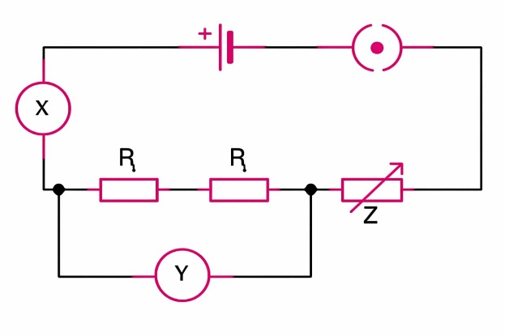
Figure 3
- Rheostat, resistor, ammeter C. Ammeter, voltmeter, rheostat
- Voltmeter, ammeter, rheostat D. Rheostat, ammeter, voltmeter
- A glass capillary tube is placed in a beaker of water. The water level inside the tube is higher than the water level outside due to:
- Cohesion B. Adhesion C. Surface tension D. Elasticity
- A horizontal plate of area 0.036 m² is beneath the surface of coconut oil with a density of approximately 930 kg/m³. The force on the plate due to the pressure of the oil is 290 N. What is the depth of the plate beneath the surface of the oil?
- 0.87 m B. 1.13 m C. 8.7 m D. 9.1 m
- When a force is applied to a given material, the material returns to its original shape after the force is removed. This behaviour is termed as:
- Plastic deformation C. Elastic deformation
- Irreversible deformation D. Viscous deformation
- A student wants to compare the densities of two different liquids. Which instrument should the student use for direct comparison?
- Barometer C. Hygrometer
- Thermometer D. Hydrometer
Answer
(i) | (ii) | (iii) | (iv) | (v) | (vi) | (vii) | (viii) | (ix) | (x)

Student’s assessment number…………………
- Match the description of the forces in List A with its corresponding meanings in List B by writing the letter of the correct answer below an item number in the table provided.
(5 marks)
List A | List B
- Tensional force  - Buoyant force  - Torsional force  - Frictional force  - Normal force | - This is a nuclear force that binds protons and neutrons together to form atomic nuclei.  - Is the force that includes both electric and magnetic forces.  - Is the force which opposes the motion between two surfaces of objects in contact.  - Is the force exerted on an object by a stretched material.  - This is the support force exerted upon an object which is in contact with another stable object.  - Is the force that causes objects to float  - Is the force that produced on a solid object when is twisted.

Answers
Item number | (i) | (ii) | (iii) | (iv) | (v)
Answer

SECTION B (70 Marks)
Answer all questions in this section
- (a) You observe a stone and a leaf placed in a river. One sinks rapidly, and the other gently floats on the water’s surface. Explain the factors responsible for this difference in behaviour. (4 marks)
…………………………………………………………………………………………………………………………………………………………………………………………………………………………………………………………………………………………………………………………………………………………………………………………………………………………………………………………………………………
Student’s assessment number…………………
(b) State three applications of magnets. (3 marks)
- ………………………………………………………………………………………………………………………………………………………………………….
- …………………………………………………………………………………………………………………………………………………………………………
- …………………………………………………………………………………………………………………………………………………………………………
(c) A block of metal has a mass of 264 g. The block is totally immersed in water filling up a eureka can. If 24 g of water overflows through the spout of the can into a beaker, calculate the relative density of the metal. (3 marks)

- (a) Explain why our ears pop when going on mountain? (3 marks)
………………………………………………………………………………………………………………………………………………………………………………………………………………………………………………………………………………………………………………………………………………………………
(b) Mention three factors that pressure in liquids depends on. (3 marks)
- ………………………………………………………………………
- ………………………………………………………………………
- ……………………………………………………………………….
Student’s assessment number…………………
(c) In a hydraulic brake system, the piston in the master cylinder has a diametre of 2.0 cm and the piston in the slave cylinder has a diametre of 3.5 cm. The brake pedal is pushed down 10 cm with a force of 50 N. How far do the brake shoes move and with what force do they press against the brake drum?
(4 marks)

- (a) Write three equations of motion when a body is thrown straight into the air (3 marks)
- ………………………………………………………………………….
- …………………………………………………………………………….
- ……………………………………………………………………………
(b) A car starts from rest and accelerates uniformly at a rate of 4 m/s² for 6 seconds. It maintains a constant velocity for 20 seconds. The brakes are then applied, and the car decelerates for 3 seconds. Find:
(i) The maximum velocity attained. (2 marks)
(ii) The total distance covered. (5 marks)

Student’s assessment number…………………

- (a) Both potential energy and kinetic energy are forms of mechanical energy. How do they differ? Give two points. (4 marks)
- ………………………………………………………………………………………………………………………………………………………….
- ………………………………………………………………………………………………………………………………………………………….
(b) Give any two cases in which work done will be zero. (3 marks)
- …………………………………………………………………………………………………………………………………………………………
- …………………………………………………………………………………………………………………………………………………………
(c) With aid of diagram show the forces acting on a pendulum bob tied on a string. (3 marks)

Student’s assessment number…………………
- (a) Give three factors in which the capacitance of a capacitor depends on?
(3 marks)
- …………………………………………………………………………
- …………………………………………………………………………
- …………………………………………………………………………
(b) A sharp needle was brought close to the cap of a charged leaf electroscope. Explain why the leaf collapsed? (2 marks)
………………………………………………………………………………………………………………………………………………………………………………………………………………………………………………………………………………………………………………………………………………………………………………………………………………………………………………………………………………………………………………………………………………………………………………
(c) Determine the effective capacitance and charge stored in the circuit shown in Figure 4. (5 marks)
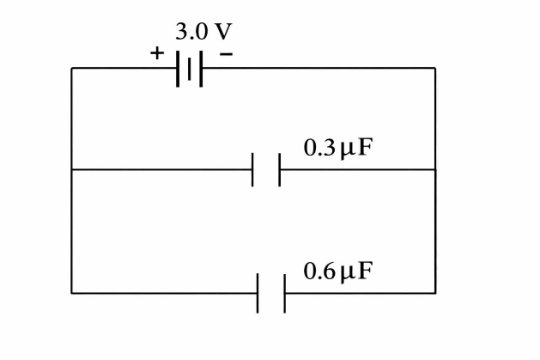
Figure 4

Student’s assessment number…………………
- (a) What is a leaf electroscope? (2 marks)
…………………………………………………………………………………………………………………………………………………………………………………………………………………………………………………………………………………………………………………………………………………….
(b) Draw a leaf electroscope and label its four parts. (5 marks)

(c) Explain what happens when an ebonite rod is rubbed with fur. (3 marks)
………………………………………………………………………………………………………………………………………………………………………………………………………………………………………………………………………………………………………………………………………………………………………………………………………………………………………………………………………………………………………………………………
- (a) Give the difference between zero error and parallax error. (4 marks)
……………………………………………………………………………………………………………………………………………………………………………………………………………………………………………………………………………………………………………………………………………………………………………………………………………………………………………………………………………………………………………………………………………………………………………………………………………………
Student’s assessment number…………………
(b) The diameter of a solid metal sphere is measured using a micrometre screw gauge. Figure 4.17 shows an enlarged shaft of the micrometre screw gauge when taking the measurement.
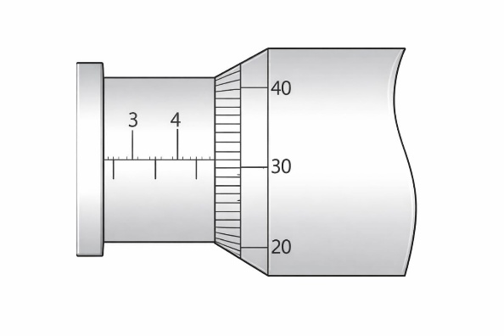
Figure 5
If the mass of the sphere is 0.450 g. What is the density of the metal used to make the sphere? (6 marks)

Student’s assessment number………………….
SECTION C (15 marks)
Answer question 10
- (a) State the which gives the relationship between voltage and current.
(2 marks)
……………………………………………………………………………………………………………………………………………………………………………………………………………………………………………………………………………………………………………………………………………………
(b) James is a student at a certain school; he wants to study how voltage and current relate. What are the five important apparatus should James consider in order to achieve his aim. (5 marks)
- …………………………………………………………………………….
- …………………………………………………………………………….
- …………………………………………………………………………….
- …………………………………………………………………………….
- …………………………………………………………………………….
(c) An electric cell with minimal voltage, E_{m} has a resistance of 3 Ω connected across it. If the voltage falls to 0.6 Е, calculate the internal resistance of this cell.
(4 marks)

Student’s assessment number…………………
(d) A nichrome wire has a cross-sectional area of 4×10⁻⁸ m² and a resistivity of 1.0x10⁻⁶ Ωm. If a resistor of resistance 11 Ω is to be made from this wire, calculate the length of the required wire. (4 marks)

